The shattered moon in the night sky:
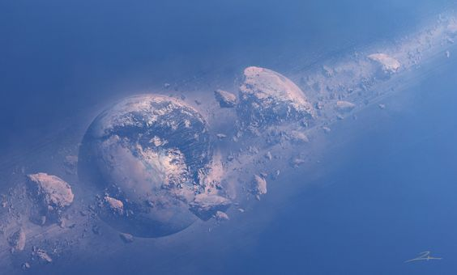
Hunters return to Highvale from a successful outing with plentiful game:


