Sorcerer-Kings
Sorcerer-Kings is a dark sword & sorcery setting, where the lands are dominated by city-states run by the eponymous rulers who hold iron sway over the lands through their dark magic. Play began in the city-state of Baan Tash, run by a cabal of Sorcerer-Kings that few ever see from their spire above the city. Employing an army of the dead, and a hierarchy of priests and secret police, they ensure that their populace continues to be a source of power for their magic.
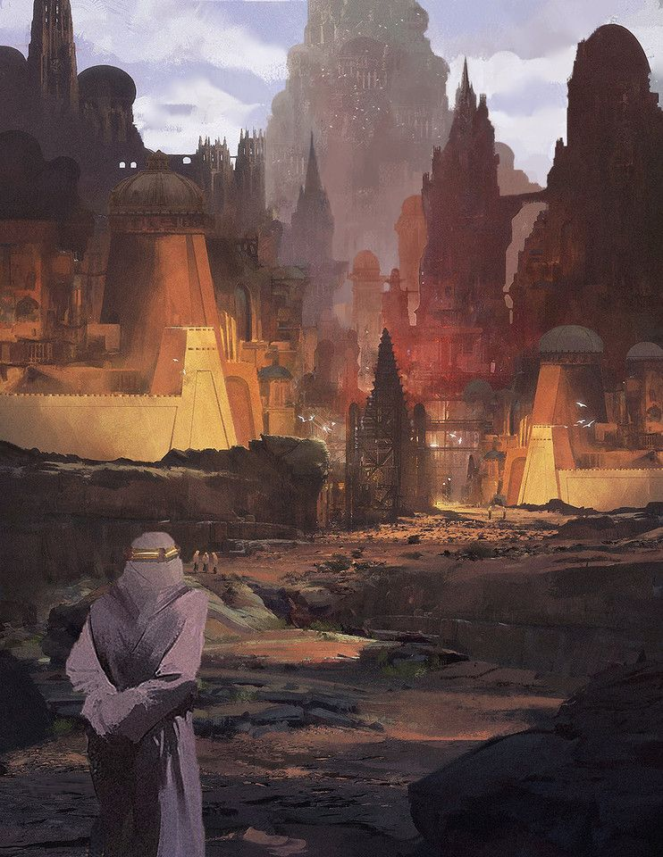The City of Baan Tash
The City of Baan Tash

Characters
Huruzin - Mike Holmes' heretic sorcerer, looking to understand a measure of the Sorcerer-kings' power.
Ithamon - Shreyas's traveling inquisitor from a fascinating neutral order.
Ariesixia - Char's murderous order member, betrothed of Huruzin

