New Alderaan
Part of Rays of Hope.
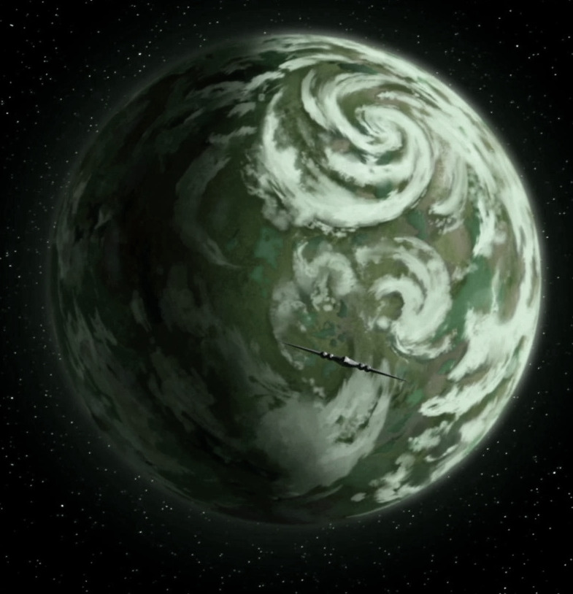
The world discovered by Bridge Two. It is large, with a breathable atmosphere and varying temperature. It is broken into two distinct climates: The highlands, and the lowlands.
In the highlands, there are countless hills and many mountains. The climate is generally cold, wet, and stormy. At the top of many hills and along the edges of many mountains are castle like ruins of a low lost civilization. No language has been found, except for advanced devices that all seem to await commands somehow. Descending to the low lands means passing through a dense canopy of incredibly large trees, the fruit of which emit light when leaves are exposed to it from above.
In the lowlands, below the canopy it is a swamp jungle of force critters not unlike Degobah.

