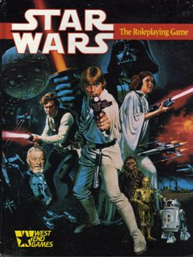
(I make no claim to Star Wars, or the West End Games RPG, the graphic is just for reference to the source material!)
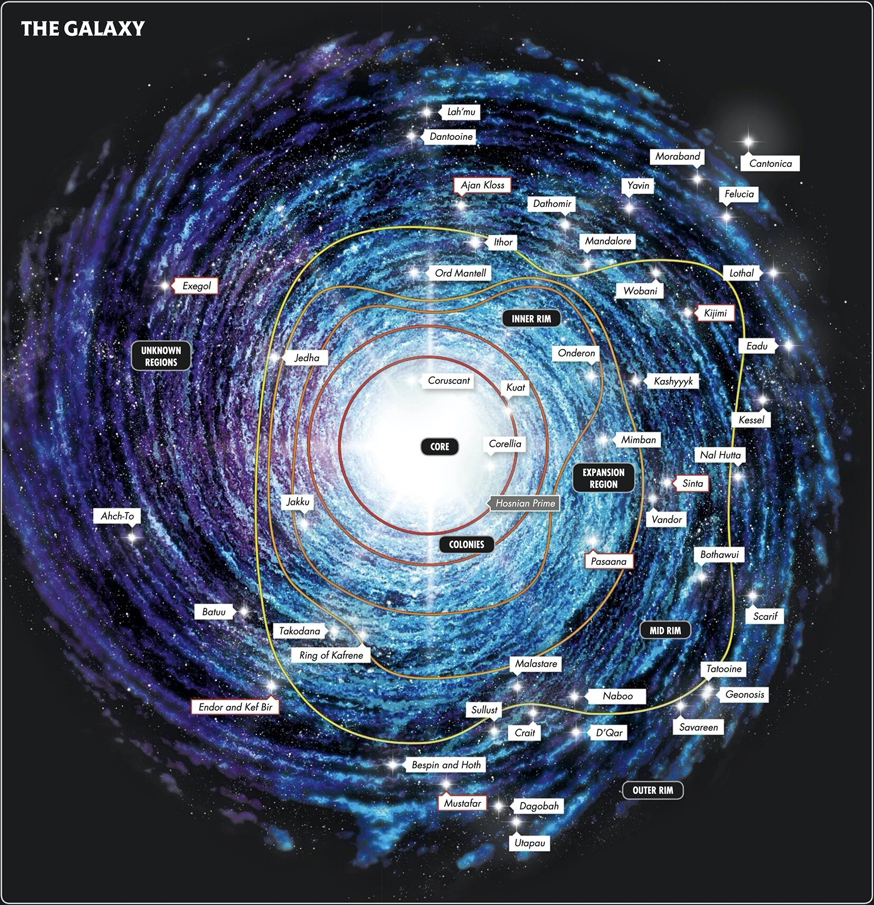

Simple Six, in a nutshell
Simple Six is a re-imagining of Star Wars D6 as published in 1987 by West End Games. It shares much in common with the game, and can be used with it's source books, and extended rules. Note: this is based on first edition not second. Its is very much not compatible with second edition, unless you make many adjustments. The changes between the editions were rather sweeping.

Die Codes and Dice
Action ratings are rated in die codes, just as challenges (difficulty) against them are. A die code is listed as Xd + Y. 1d+2 is a valid die code. However the Y bonus can't ever be higher than 3. When it reaches 4, you flip the die up one and return to zero. Increasing 2d+3 by one gives you 3d+0, 3d. Sometimes rolls get a boost: This is listed as dice. A boost of 2d increases the die code that much for the roll. If you had 2d boost on your 2d+3 die code, you have 4d+3 for that roll.
How good is a given action die code?
- Below 3d, not so good. 3d, good. 5d great, 7d awesome, 9d legendary, 11d mythical!
How hard is a challenge die code?
- 1d+1, easy. 2d+2 not-so-easy. 3d+3 hard. 5d+1, wow. 6d+2, oh my!. 7d+3 the stuff told about in legends.
Some notes:
- A die code lowered below 1d is valid till 1d-2, then it halts. You can never roll less than 1d-2.
- Roll results that would be less than 1, equal 1.
- If you are surprised that the challenges look lesser than the action die code, you'll see why below.
- Dice in SimpleSix cost +4 (4 pips) and are worth that, unlike 3 pips from the original design. As I see it, this lessens the “jump” when moving from dice 2d+3 goes to 3d, which isn't inherently good or bad, just different from the old game. Moving up a die in SimpleSix is more like pause than a jump, 2d+3 and 3d are quite similar statistically.

Rolling the Dice, 3 Roll Types
There is only one hard rule for when to roll in Simple Six: Only roll when it matters. A roll in the game has to have a major impact on the adventurers themselves or what matters to them. There are implications from this rule that shape the game, and you can read more about that in Establish What Matters. Once that condition is met, the GM has to decide the category of the roll using the following rules:
- Does it have attached Jeopardy? Specifically, will a failure of the roll cost the adventurer something that matters, or injury them in some way (not always physically)? If so, this is a Roll with Jeopardy attached, stop.
- Does it risk immediate (or clearly upcoming) opportunity? Specifically, will a failure cost the adventurer the change at something they need towards an established goal. If so, this is a Roll with Clear Risk, stop.
- If the roll fits neither category above, it is a roll that may change the direction of play in the eyes of the GM. The result will shape things that are important to the larger story but not directly impacting the character themselves at the moment. This is a Roll with Inspiring Implication, stop.
Each type of roll puts a special demand on the GM before the roll is made.

Roll with Jeopardy
These are the most grave rolls made in the game. A lot of rolls in combat are of this nature. First, the player should see these rolls coming. It is bad practice as a GM to sucker-punch a player with a surprise Jeopardy roll, with few exceptions, see Handling Surprises. Second, determine what is at risk with the roll. This is the thing the player will lose if they fail to succeed. Be clear that the loss may be permanent, or at the least costly to recover. Injury (health) in combat is a normal risk to attach to action rolls for battle.

Roll with Clear Risk
If the roll may cost an adventurer (or adventurers) an opportunity, it is a roll with Clear Risk. First, in these cases, be clear about the opportunity that will be lost on failure. Then you are ready to roll. Han Solo attempting to sneak up on a Storm Trooper to get a surprise attack, perfect example of a Sneak roll with Clear Risk. Sometimes however, the loss of opportunity might not be as clear, so make efforts to establish it before the roll. Your bounty hunter heading down a network of dimly lit alley ways looking for the properly marked door of a private club would be a Search roll. In this case the implication being the method being used to find that club is lost. This doesn't mean the adventurer won't find the club eventually, they will just have to use another method.
If Clear Risk and Jeopardy seem similar, they are. The primary difference is that what is lost with Jeopardy can be impossible or costly to regain. The loss of Opportunity can be mitigated. Essentially any valid reason created in the fiction to regain it by the play should be accepted. While the situation with Solo above doesn't give many options, the bounty hunter looking for the club could just find a guide and try again tomorrow. But of course, some of that needs played out in the fiction and it did cause a delay.

Roll with Inspiring Implication
Now we have come to the interesting roll category for the GM more than the player. The type of roll also implies how the game should be run, the style of GMing needed to make it work. The roll with Inspiring Implication doesn't cost the adventurer opportunity, or does it place them in any jeopardy. However the roll occurs because it may shape the flow of the story around the players and help set the stage for things in the future. Ok, that is really vague. Let me try again: As the GM you should always be building and refining your sandbox. This is the world in which the adventurers live, it is the stage of the story of the game. In this sandbox you have characters who are not the adventurers. They have their own goals, drives, weaknesses, and history. It is these Notable characters and Villains that may be affected by rolls in this category. In return, their actions change and your sandbox shuffles a bit.
Here are some good examples of such rolls:
- Your smuggler checks into a spaceport under a fake identity. A Con roll is made to be convincing enough such that the port control officer doesn't report this to a local crime lord.
- Your droid is repairing the hyperdrive of your stock light freighter. A Starship Repair roll is made to notice the tracking device left in it from a secret organization tracking the ship's exploits.
- Your pilot is drinking at a local watering hole and trying to get a point across to a green eyed snake-looking alien. A languages roll is made to see if their knowledge impresses the locals who are interested in the newcomer.
Note, the result of these rolls will be established in the fiction with a scene, even if the adventurer themselves is unaware of the outcome. This is one common method to avoid the sucker-punch talked about above in Jeopardy.
This is also the roll type that really drives home that the adventurers are heroes (even if they don't know it). Here are examples:
- After a blaster firefight on the streets downtown, you clear out the marauders that have come to pillage the ruins of a once great town. A Blaster roll is made to impress a young man and lead him to form a band of protectors to keep the town safe.
- Working endlessly to repair the damage to a courier ship, a Stamina roll is made to inspire the crew and their captain to take action against the pirates of the sector.
- After searching out all the sacred refugee Mon Calamari on a world once dominated by a terrible Emperor, a Search roll is made to inspire the city's Lord to open it's borders to all refugees.
The outcome of these rolls always changes the way in which the Force flows around the adventurer. If they fail they earn flow and if they succeed they lose it. How flow can be used is down in Flow.

Rolling the Dice, Mechanics
So when it comes time to finally make the roll, you roll all your six-sided dice and sum them plus the modifier. 2d+2 becomes: 2d6+2. The GM rolls the challenge dice the same way. Then you compare:
- You rolled under half the total of the challenge: Things went horribly wrong - Oh Boy.
- You rolled less than the total of the challenge: You didn't get by - Failure.
- You rolled more than the total of the challenge: You got by - Progress!
- You rolled more than twice the total of the challenge: Things went right - Success!
Here is a breakdown of how to handle each result for both the GM and player of the adventurer in question:

Oh Boy
You've hit a snag. Well, more like a brick wall. Things have gone so wrong, there is no way forward. Whatever being attempted, its over for now. The player of the adventurer defers to the GM for the reason, or offers a choice of up to three options from the GM it pick from. The player narrates the results of the roll, with a closing added on to the end by the GM as desired. The adventurer earns 1 Flow, or more if the GM awards more.

Failure
You didn't get by. No progress has been made towards the goal of the action. You may however, press forward, giving the GM a boost die on the next challenge roll. The player narrates the results of this action and how they didn't get by. The GM adds a closing narration as desired.

Progress
You got by, and have made progress towards the goal. If the action was uncomplicated (see Complications In The Action), or you have earned enough progress, move to success. Otherwise, record one progress and take a boost die for your next roll. The GM narrates the action and the player can add in a closing as desired.

Success
Thing went right, and you've succeeded! The end goal is reached. GM and Player narrate the outcome together as they agree.

Creating Adventurers, Pick a Level!
In order to create an adventurer, decide on their level:
- 3: Ordinary.
- 5: Special.
- 7: Hero.
- 9: Legend.
Once you have a level you have:
- 3 + Level * 2 Attribute dice to place between: Dexterity, Knowledge, Mechanical, Perception, Technical. You may split a die into +4 bonuses, as long as no bonus exceeds +3.
- 3 + Level Strength dice to place between: Body, Force, and Genius. You may not split dice for these.
- Level dice in Skills/Talents. Skills are listed under each Attribute, Talents under each Strength. You may not place more than three dice into any one Skill/Talent.
- - There are specific restrictions on Force talents based on the die code of the Force Strength itself. See The Flow of the Force.
The GM will set the “level” of the game. This is the maximum level you can take in a character. If you choose to take a lesser level, you'll get certain abilities under The Flow of the Force.

Adventurers: Attributes & Skills
- Dexterity: Coordination, Balance, and physical finesse.
- Knowledge: Education, learning, and even experience to some degree.
- Mechanical: Mechanical aptitude, operating complex devices, mostly.
- Perception: Powers of observation, sharpness of senses, and ability to read between the lines.
- Technical: Technical aptitude, the mastery of technology invention and repair.
Dexterity | Knowledge | Mechanical | Perception | Technical
Blaster | Aliens | Astrogation | Bargain | Computers
Dodge | Bureaucracy | Beast Riding | Command | Demolition
Heavy Weapons | Cultures | Driving | Con | Droids
Melee | Languages | Starship Gunnery | Gambling | Medicine
Thrown | Planets | Starship Piloting | Hide & Sneak | Repair
Unarmed | Streetwise | Starship Systems | Search | Security

Adventurers: Strengths & Talents
- Body: Strength of body, toughness, etc.
- Force: Affinity with the Force.
- Genius: Strength of brilliance, cunning, etc.
Body | Force | Genius
Athletics | ~talent~ | Insight
Brawling | ~talent~ | Invention
Lifting | ~talent~ | Mechanical
Stamina | ~talent~ | Technical
Swimming | ~talent~ | Schemes
Toughness | ~talent~ | War
Force Talents are specific to each Force user, and therefore created by the player of that adventurer with the assistance of the GM.

Creating Adventurers, Finishing Touches
To finish an adventurer you need the obvious, name, appearance, etc. But also: Background, Personality, A Quote, and Connection to Others. These should all be vague, allowing you to build on them during play.

Background
A brief idea of where the adventurer came from. A one line summary, and perhaps some further highlights is the right amount of background for a starting adventurer. Usually you include a homeworld here, and some idea of why they became an adventurer.

Personality
A short summary of the kind of demeanor and personality the adventurer has, you can make this super-short “joker” or expound as you wish. This is meant to inspire your roleplay, nothing more.

A Quote
Perhaps a favorite phrase, or just something notable the adventurer has said. It should make a statement about who they are. A smuggler's example from the original game: “I don't have the money with me.”

Connection to Others
Your adventurer has to know at least one other adventurer. It is important that this relationship matters to them, the adventurers are always a group that has each other's back.

Creating Adventurers, Hero Templates
First, a blank adventurer template page: Adventurer Template.

A Method for Cinematic Sequences
(To be filled in)

Considerations for Narration

Establish What Matters

Handling Surprises

Notable Characters and Villains

Considerations for Mechanics

Resolving Advantage for Boost
This can be as simple and complex as the GM decides for each action. Here are some examples of more complex methods which can be used to figure out Advantage in situations, and then the highest Advantage (by dice) gets that boost to their action:
- Firefight: Weapon dice as Advantage to the attacker, Body+Armor as Advantage to the defender.
- Dogfight: Weapon dice + Maneuver to the attacker, Shield + Maneuver to the defender. (Hull is body strength for starships, etc.)
- Hacking: Gear dice + Wisdom to the offense, System + AI to the defender.
- Sneaking: Gear dice + Environment boost to sneakers, Gear dice + Environment boost to searchers.
- Politics: Clout dice + Wisdom to agressor, Clout dice + Wisdom to resistor.

Complications in the Action

Advantage Die Codes

Complicated Considerations

The Flow of the Force
The Force is life energy, and it flows around all living things. This game makes the assumption that all living things have some affinity to the Force, and life can't exist without it. In this way all adventurers have a Force strength. If that strength is 2d or below, it is small enough that it is not noticeable to the adventurer. At 3d, the adventurer has some small awareness of the flow of it around them. It is at this level they can begin to use force talents. Here is a simple benchmark for talents based on Force strength:
- 3d Force: Sensing only.
- 4d Force: Sensing, deep sensing (analysis of talents), minimal influence - one influence talent only.
- 5d Force: Sensing, deep sensing, moderate influence - two influence talents only.
- 6d+ Force: Any talent, fully awakened to the force.
If you create an adventurer of lower level than the GM sets for the game, you end up with a Force Sensitive adventurer and the following rules are added to your adventurer sheet:
- One level below:
  - If the adventurer's Flow is below 3, gain one at the start of any action roll.
- Two levels below:
  - If the adventurer's Flow is below 3, gain one at the start of any action roll.
  - Earn one Flow at the start of each scene for 0 XP cost.
Don't create an adventurer more than two levels below the one set by the GM for the game you are playing.

Sandbox and Keeping Pace
(To be filled in)

The Dark Side
In the original game, the Dark side was strictly defined and an adventurer could be lost if they gained enough Dark Side points. While SimpleSix takes a simple approach to right and wrong, good and bad, like the original trilogy did, it doesn't have such silly simple rules. It takes the view that the Force is life energy, and its energy is the Flow of it, for good or bad. There is no real dark side or light side, but thinking that makes it so. It takes the view that the light side and dark side in the fiction of Star Wars is a rigid structure created by the force users themselves. The GM and players are welcome to explore these concepts as they wish, but the game takes no sides and does not enforce any morality points.

Conditions: XP, Flow, Drains, Recovery

XP & XXP
XP is the currency of the game and storytelling overall. XP is award to characters from story events, achieving goals, and it drips in addition (1 at the start of each session always). XP can be used to buy Flow. The cost is the amount of Flow bought in the current scene + 1. So the first Flow bought in a scene costs 1 XP. Next costs 2 XP, then 3 and so on. It can get expensive to buy a lot of flow at once! When you have spent your XP, it becomes XXP, short for eXpended XP. In this state you can use it to increase skills and attributes between sessions:
- Skills/Talents: Pay XXP equal to its die code to increase it +1 (flipping to +4 becomes +1d+0).
- Attributes: Pay XXP equal to its die code + 3, to increase it +1 (flipping to +4 becomes +1d+0). Can only be done twice (mark a ! next to an improved attribute, and never have more than !!).
- Strengths: Pay XXP equal to its die code + 5, to increase it +1 (flipping to +4 becomes +1d+0). Can only be done twice (mark a ! next to an improved attribute, and never have more than !!).
Charity: You make expend 2 XP, making them into 2 XXP, to given another adventurer 1 XP at any time.

Flow
Flow is the rushing of the force around the adventurer. The more Flow, the more the Force is with them in the moment. Flow can be used two ways:
- At the start of a scene, to reduce Drain. Pay 1 or 2 Flow to reduce that much Drain. You may do this only once.
- To gain +3d boost to action your adventurer is taking in cinematic action. The GM may increase the boost if the action is particularly heroic or sacrificial.
Flow can be reduced below zero, so -3 Flow is valid. This acts as you would expect, it soaks up XP spent to raise it or any other Flow your adventurer may gain. A major cause of this can be Recovery below.
Charity: At any time you may pay 2 Flow to give another adventurer 1 Flow in cinematic action together.

Drains
Drains are anything in the game that works against the strengths of an adventurer and may hamper their efforts. Drain is taken from conditions, which are recorded by themselves with their drain die rating, and then added to the total against a strength. In this way there is drain against: Body, Force, and Genius.
- Body Drain: Major types include injury, poisons. Limited types include exhaustion, environmental.
- Force Drain: Major types include injury, force corruption. Limited types include force burn, expended will, environmental.
- Genius Drain: Major types include injury, misery, derangement. Limited types include confusion, sadness.
Note that injury can inflict all drains. Limited types clear up themselves, meaning all limited drains are reduced 1d at the end of scene (or as the GM sees fit). Major drains are harder to remove. Make sure you make limited drains with an L so you remember to reduce them.
Drains are serious business, because they are additive. If you have 3d body injury from a blaster shot and get 2d body injury from a kick that is 5d body drain of injury!
Removing total Drain with Flow does not remove the condition itself. The GM can trigger it again later against your adventurer as part of a rolled Failure.
Your adventurer ignores total drain equal to or less than their strength for each type. Once you have more dice of drain total than the strength you have dice of weakness equal to that amount. Here is how that works:
- When the GM declares it works against your actions: Add weakness dice as a boost to the challenge of an action.
- At your choice, or whenever you have 6d (highest of the three) or more weakness: Your adventurer is out of action for the scene. Gain 2 XP.

Recovery
Limited conditions recover themselves at a rather quick rate. Major ones though have to be recovered with recovery. Given the GM decides your adventurer has access to a method of recovery for a major condition (might need rolling, depends on the situation), you can buy it off with Flow. The cost to recover a major condition is it's die code in Flow. This may push Flow negative, and that is acceptable (meaning you have a Flow debt). Such a Recovery also reduces total drain of that type by the same amount as a bonus.

