General
- Adventurer (starting level): Tronce Porto (7)
- Species: Human
- Player: Mike
- Appearance: See pic lower left
- Background:
- Personality: Taciturn and thoughtful
- Quote: “You didn't hear this from me, but…”
- Connection(s):

Attributes/Skills
3d+1 Dexterity | 4d+2 Knowledge | 2d Mechanical | 5d Perception | 3d Technical
3d+2 Blaster | – Aliens | – Astrogation | 5d+1 Bargain | – Computers
– Dodge | 5d Bureaucracy | 3d Beast Riding | 5d+1 Command | 3d+1 Demolition
– Heavy Weapons | – Cultures | – Driving | 5d+1 Con | – Droids
– Melee | – Languages | – Starship Gunnery | – Gambling | – Medicine
– Thrown | 5d Planets | – Starship Piloting | 5d+1 Hide & Sneak | – Repair
3d+3 Unarmed | 5d+2 Streetwise | – Starship Systems | 5d+1 Search | 3d+2 Security

Strengths/Talents
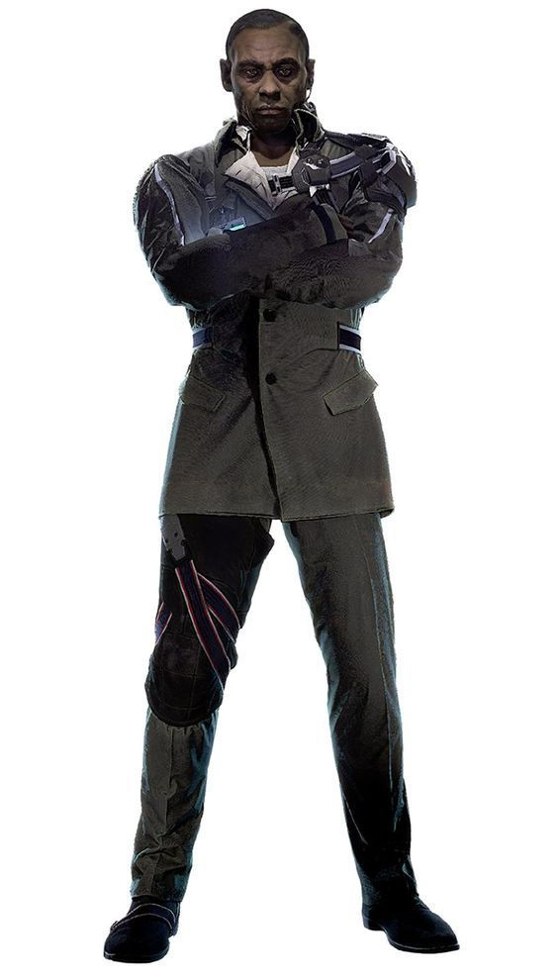
4d Body | 2d Force | 4d Genius
– Athletics | – ~talent~ | – Insight
– Brawling | – ~talent~ | – Invention
– Lifting | – ~talent~ | – Mechanical
– Stamina | – ~talent~ | – Technical
– Swimming | – ~talent~ | 4d+2 Schemes
– Toughness | – ~talent~ | – War

Condition / Status
XP > | Flow > | Body Drain (?D) | Force Drain (?d) | Genius Drain (?d)
– | – | – | – | –
- XXP (eXpended XP): 0
- Condition…

Flow of the Force
- Special rule…

Notable Gear/Equipment
- This
- That

Contacts, History
- Contact/Note/etc…

